Blackboard Grade Center: Last Date of Activity Column
For financial aid purposes, you need to keep track of your students' last date of activity (or attendance), which you will be required to report to the College three times throughout the term: beginning (never attended or NA), midterm (quit attending or QA), and end (when you enter a date). To maintain these records for auditing purposes, DMACC requires instructors to have a designated Last Date of Activity column in their Blackboard gradebook.

Follow the steps below to add this column to your Grade Center. Make sure you keep it updated throughout the semester.

Set up the Column
- Go to the Full Grade Center of your course.
- Click the Create Column button near the top.
- In the Column Name field, type "Last Date of Activity."
- In the Primary Display drop-down, select "Text."
- In the Points Possible field, type "0." 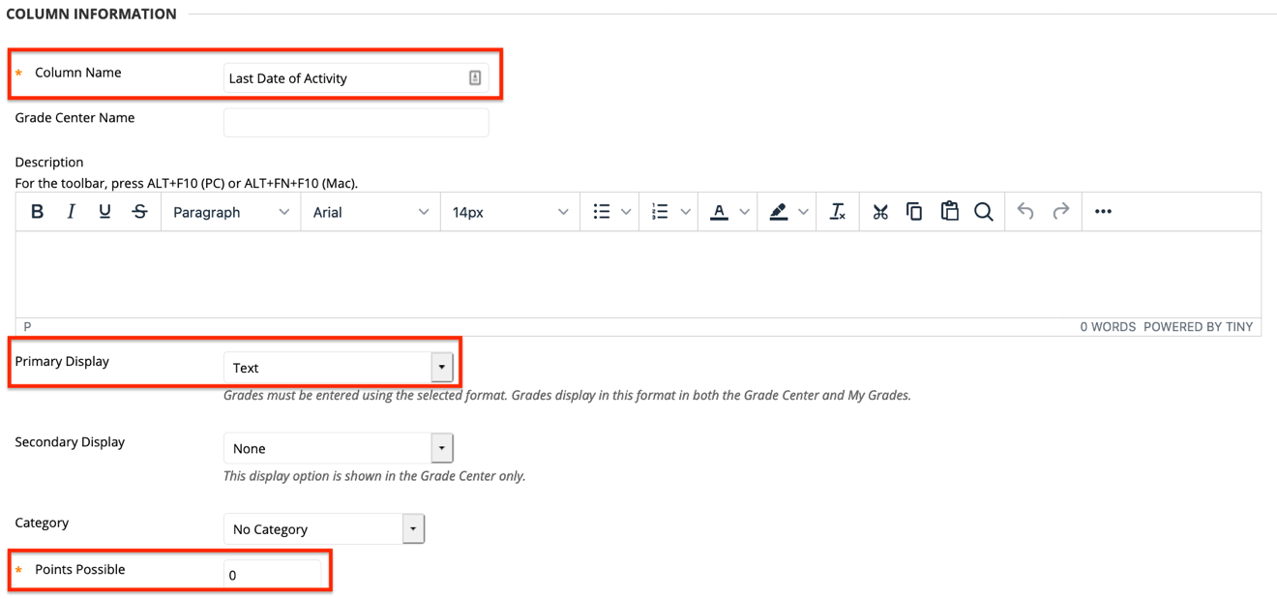
- Scroll down to the Options section and for Include this Column in Grade Center Calculations option, switch the radio button to "No."
- For the Show this Column to Students option, switch the radio button to "No."
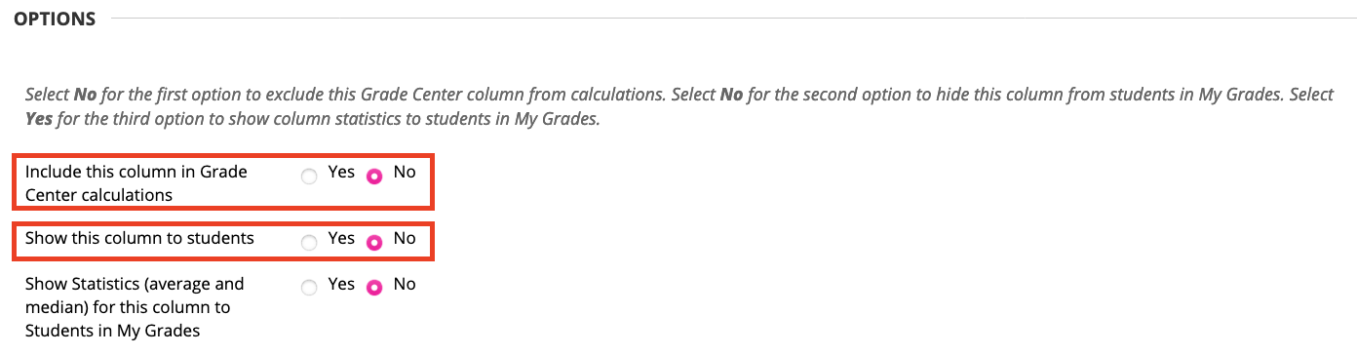
- Click Submit.

Move the Column (optional)
After you've added the column, you can move it if you wish. Many instructors prefer it near the beginning or at the end of their gradebook.

- From the Full Grade Center, click the Manage drop-down menu.
- Select Column Organization.
- Find the Last Date of Activity Column and click and hold the cross arrows icon () next to it to drag it where you want.
- Release to drop it into place.
- Click Submit.

Enter Dates
- Go to the Full Grade Center.
- Click in the cell for each student and type in the date.
  - We recommend using the format MM/DD/YYYY so you can sort your Grade Center by that column if you want.
    - Click on the column name to sort by that column either ascending or descending. You can always click on the Last Name column afterwards to readjust the sort. The yellow triangle indicates which column is used for sorting and whether it is ascending or descending.
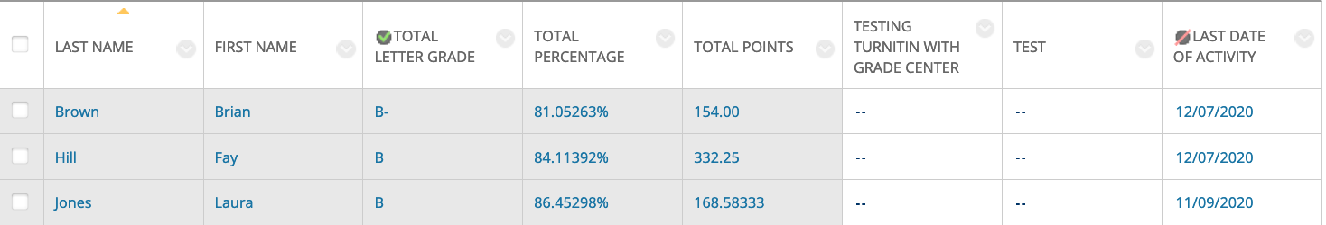

Note: The Blackboard Grade Center includes a Last Access column, which lists the date that a student last logged in to your course. This is helpful to see, at a glance, if students have been in the course, but it is NOT a good indication of activity. That is why it is important to keep your Last Date of Activity column up to date.
Need Help?
Contact one of our instructional designers.

